# HCL Tax Risk Management

With increased focus in the area of tax among different authorities around the world, compliance and an accurate tax reporting mechanism are key measures for success of any organization’s financial risk management program. Organizations with global operations running across multiple business lines need to devise more effective ways of consolidating and analyzing tax-related risks reported in multiple currencies.

The Tax Risk Management app-pack developed by HCL provides a systematic and automated way to perform tax risk reporting and analysis for managing tax obligations effectively and minimize adverse impacts on reputation, income statements, and profitability.

On this page

* Release history
* Overview of HCL Tax Risk Management App-Pack
  + Key features and benefits
  + Prerequisites (ODA and App-Pack requirements)
  + Compatible Use Cases and Applications
    - Related Applications
* HCL Tax Risk App-Pack components
  + Architecture diagram
  + Swim Lane diagram
  + Applications
  + Personas and Access Roles
* Using HCL Tax Risk Management App-Pack
  + Task 1: Assessment initiation
  + Task 2: Assessment response
  + Task 3: Assessment review and analysis
  + Task 4: Assessment closure and risk reporting
* Installing HCL Tax Risk App-Pack
  + Installation overview
    - Task 1: Prepare for the installation
    - Task 2: Install the package
    - Task 3: Setup data feeds
    - Task 4: Test the installation
    - Task 5: Manual changes
  + Installing the package
    - Task 1: Backup your database
    - Task 2: Import the package
    - Task 3: Map objects in the package
    - Task 4: Install the package
    - Task 5: Review the package installation log
  + Manual changes

## Release history

Last updated: September 2018

## Overview of HCL Tax Risk Management App-Pack

### Key features and benefits

The HCL Tax Risk Management app-pack provides the ability to perform the following functions as a part of any organization’s tax risk management process, enabling risk analysts and coordinators to:

* Perform quarterly tax risk assessments at entity/division levels.
* Roll up assessment results to country and group company levels.
* Report and analyze tax risks in local and group currency.
* Analyze historical risk data trends with the ability to quantify changes due to currency fluctuations and other risk attributes.

Key benefits include:

* Systematic and streamlined risk reporting and analysis mechanism with holistic view of organizational tax risk exposure at multiple levels.
* Engagement of highly skilled workforce in data analysis and risk assessment rather than manual data gathering.
* Aid in financial decisions such as hedging against currency fluctuations.

### Prerequisites (ODA and App-Pack requirements)

| Components | Recommended Software |
| --- | --- |
| ODA License | 4 required ODA licenses  1 optional ODA license |
| Questionnaires | 2 Questionnaires  **Note:** At least one Archer use case that leverages questionnaires must be licensed for questionnaires to function. |
| Archer | Archer 6.5P2 and later |
| Use Cases | Issues Management |
| Pre-requisite Applications | Findings  Remediation Plans  Exception Requests |

### Compatible Use Cases and Applications

#### Related Applications

| Application | Use Case | Primary Purpose(s) of the Relationship |
| --- | --- | --- |
| Company | Enterprise Catalog | Provide linkage to enterprise structure |
| Division | Enterprise Catalog | An entity being assessed can link to any division within the organization |
| Business Unit | Enterprise Catalog | An entity being assessed can link to any business unit within the organization |
| Findings | Issues Management | Tax Risks reports can be linked to Issues and tracked for closure |
| Risk Register | Risk Catalog | Tax risks can link to existing risk within the Risk Catalog |
| Exception Request | Issues Management | Issues pertinent to tax risks can be accepted for exposure as an exception to existing corporate policies or organizational processes |
| Remediation Plan | Issues Management | Issues pertinent to tax risks can be tracked for appropriate remediation with business defined workflow and accountability |

## HCL Tax Risk App-Pack components

### Architecture diagram

The following diagram provides the overarching application relationship diagram between core use case applications, required and optional ODA applications, and questionnaires.

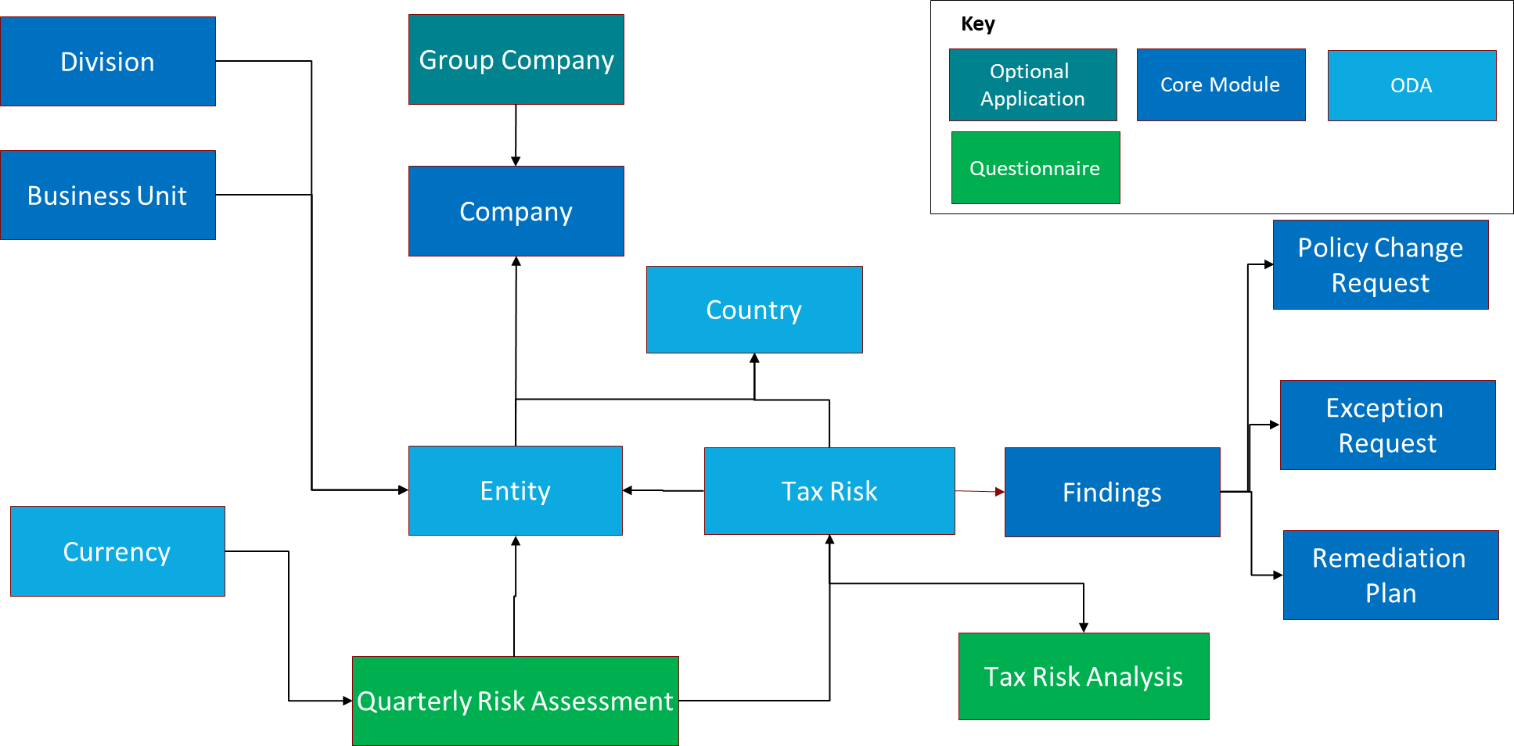

### Swim Lane diagram

The following diagram shows the general workflow of the HCL Tax Risk Management app-pack.

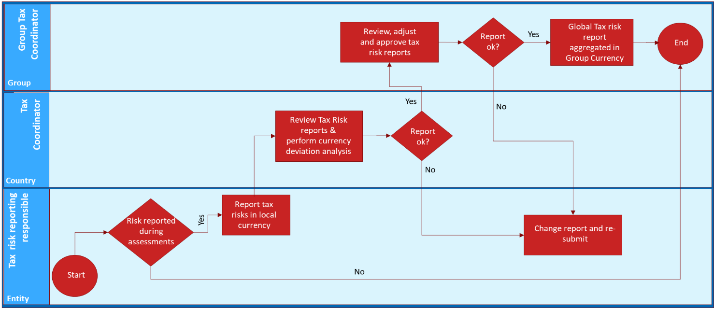

### Applications

| Application | Type | Description |
| --- | --- | --- |
| Group Company | Optional ODA | The Group Company application stores general, group tax coordinator, and taxation risk analysis information for the whole group for current quarter and year aggregated from all underlying entities across various countries. |
| Entity | ODA | The Entity application stores basic information about the organizational entity along with its geography, tax reporting responsibility, and coordinator information. It also contains tax risk analysis information for current quarter and year along with historical data from previous quarterly assessments. |
| Country | ODA | The Country application serves as a central repository of all countries where your organizational entities operate along with their local currencies. It also contains the taxation information for current quarter and year rolling up from underlying entities and linkage to exchange rates to group currency for previous quarters. |
| Currency | ODA | The Currency application serves as a central repository of currency exchange rate data from local entity to group level maintained on a quarterly basis for tax risk analysis on historical data due to currency fluctuations. It can be integrated with industry currency exchange feeds such as federal banks, open exchange rate providers, etc. |
| Tax Risk | ODA | The Tax Risk application serves as a repository of tax issues/cases along with their geographical and entity applicability, classification, financial and taxation impact along with linkages to quarterly assessments and analysis at group currency level. |
| Tax Risk Analysis | Questionnaire | The Tax Risk Analysis questionnaire allows the organization to perform tax risk analysis using the current local currency and providing the currency conversion. |
| Quarterly Risk Assessment | Questionnaire | The Quarterly Risk Assessment questionnaire allows organizations to perform quarterly assessments on tax risks reported at entity levels. It enables tax coordinators to capture tax exposure, provisions, payments, liability, and control information reported in local currencies and converted into group currency for subsequent analysis and management reporting. |

### Personas and Access Roles

The following table describes the functions that make up the app-pack’s organization roles. Depending on the organization of your company, these functions and responsibilities may vary.

| Function | Description |
| --- | --- |
| Group Tax Coordinator | The Group Tax Coordinator is responsible for governance of the quarterly tax risk reporting process including timely submission of tax risks, subsequent analysis by coordinators, and maintenance of local currency exchange rates to group currency. The Group Tax Coordinator is the final level of approval for all submitted tax reports. They define entity Tax Coordinator and tax risk reporting and are responsible for personnel management with regard to the tax risk management process. |
| Tax Coordinator | The Tax Coordinator is assigned to one or more regions. Within the assigned region, they are responsible for analysis of reported risks for currency deviation and submission of quarterly risk assessments to the Group Tax Coordinator, thereby supervising the risk reporting process. The Tax Coordinator can change a company’s tax risk reporting responsible personnel if needed while the Group Tax Coordinator is notified of the change. |
| Chief Accountant | Chief Accountants are employees of entities under the Group Company that are responsible to report the tax risks in the system for their respective areas. |

Out-of-the-box roles and groups can be extended to the Tax Risk Management app-pack application and related applications to ensure that respective stakeholders in your organization have appropriate access to the app-pack.

## Using HCL Tax Risk Management App-Pack

### Task 1: Assessment initiation

Group Tax Coordinators can initiate the quarterly assessments on scoped entities/companies for a particular quarter. Automated notifications are sent out to chief accountants for assessment cycle intimation along with due dates and instructions/guidelines for completing the assessments. The reporting currency for a particular company and quarterly exchange rate is automatically picked from the integration linkages established with supporting modules (country and currency repository).

### Task 2: Assessment response

The Chief Accountants respond to each quarterly assessment related to the entity for which they are responsible. They fill in the Exposure amounts to be reported in local currency and its distribution across various categories like taxes paid, contingent liability, provisions, and more. Across each of the quarterly assessments they can create a Tax Issue Case by filling in the details like issue name, description, type of Risk or Opportunity, Sub-Type of Risk or Opportunity, effect on income statement, and more. Each issue type can further be split across Sub-Type, i.e., categorization across Interest/Penalty and tax components. Once everything is documented the Chief Accountant sends the assessment to the Tax Coordinator.

### Task 3: Assessment review and analysis

On receiving the request from the Chief Accountant, the Tax Coordinator reviews the details provided by the Chief Accountant and the issues reported as part of the assessment cycle. The Tax Coordinator can create the tax analysis record and perform the Tax Risk Analysis by comparing the exposure changes due to absolute value and currency changes over the period of time. The Tax Coordinator has two options: he/she can either refer the request back in case change is required to the submitted report or in case of agreement can approve it.

### Task 4: Assessment closure and risk reporting

Once the report is approved at the Tax Coordinator level it reaches the queue of the Group Tax Coordinator. The Group Tax Coordinator then reviews the reports submitted by Tax Coordinator, they can make changes to the final reported amount in local currency without changing the data reported by Chief Accountant and Tax Coordinator by adding the adjustments. This adjustment is not visible to Chief Accountant and Tax Coordinator and used for final report for Management. Once everything is as expected, they can approve it else can refer it back to the Tax Coordinator. The exposures reported in local currencies are converted into group currency to aid analysis. Post closure of the assessment cycle, the risks are consolidated across companies/countries and analyzed for open exposure trend at group level over a period of time for subsequent financial reporting and to aid management decisions.

## Installing HCL Tax Risk App-Pack

### Installation overview

Complete the following tasks to install the application.

#### Task 1: Prepare for the installation

1. Ensure that your Archer system meets the following requirements:
   * Archer Platform version 6.5P2 and above.
2. Download the ODA install package from Archer on: <https://community.rsa.com/community/products/archer-grc/exchange/documentation-downloads>
3. Read and understand the "Packaging Data" section of the Archer Help.

#### Task 2: Install the package

Installing a package requires that you import the package file, map the objects in the package to objects in the target instance, and then install the package. See Installing the Application Package for complete information.

#### Task 3: Setup data feeds

You must import and schedule each data feed. See Setting Up Data Feeds for complete information.

#### Task 4: Test the installation

Test the application according to your company standards and procedures to ensure that the app-pack works with your existing processes.

#### Task 5: Manual changes

Perform the manual changes in System.

### Installing the package

#### Task 1: Backup your database

There is no Undo function for a package installation. Packaging is a powerful feature that can make significant changes to an instance. Archer strongly recommends backing up the instance database before installing a package. This process enables a full restoration if necessary.

An alternate method for undoing a package installation is to create a package of the affected objects in the target instance before installing the new package. This package provides a snapshot of the instance before the new package is installed, which can be used to help undo the changes made by the package installation. New objects created by the package installation must be manually deleted.

#### Task 2: Import the package

1. Go to the Install Packages page.
   1. From the menu bar, click .
   2. Under Application Builder, click Install Packages.
2. In the Available Packages section, click Import.
3. Click Add New, then locate and select the package file that you want to import.
4. Click OK.

The package file is displayed in the Available Packages section and is ready for installation.

#### Task 3: Map objects in the package

**Important:** This step is required only if you are upgrading to a later version of Tax Risk Solution.

1. In the Available Packages section, select the package you want to map.
2. In the Actions column, click  for that package.

The analyzer runs and examines the information in the package. The analyzer automatically matches the system IDs of the objects in the package with the object sin the target instances and identifies objects from the package that are successfully mapped to objects in the target instance, objects that are new or exist but are not mapped, and objects that do not exist (the object is in the target but not in the source).

**Note:** This process can take several minutes or more, especially if the package is large, and may time out after 60 minutes. This time-out setting temporarily overrides any IIS time-out settings set to less than 60 minutes.

When the analyzer is complete, the Advanced Package Mapping page lists the objects in the package file and corresponding objects in the target instance. The objects are divided into tabs, depending on whether they are found within Applications, Solutions, Access Roles, Groups, Sub- forms, or Questionnaires.

1. On each tab of the Advanced Mapping Page, review the icons that are displayed next to each object name to determine which objects require you to map them manually.

| Icon | Name | Description |
| --- | --- | --- |
| Awaiting mapping review | Awaiting Mapping Review | Indicates that the system could not automatically match the object or children of the object to a corresponding object in the target instance.  Objects marked with this symbol must be mapped manually through the mapping process.  **Important:** New objects should not be mapped. This icon should remain visible. The mapping process can proceed without mapping all the objects.  **Note:** You can execute the mapping process without mapping all the objects. The Awaiting mapping review icon is for informational purposes only. |
| Checkmark | Mapping  Completed | Indicates that the object and all child objects are mapped to an object in the target instance. Nothing more needs to be done with these objects in Advanced Package Mapping. |
| Missing objects | Do Not  Map | Indicates that the object does not exist in the target instance or the object was not mapped through the Do Not Map option. These objects will not be mapped through Advanced Package Mapping and must be remedied manually. |
|  | Undo | Indicates that a mapped object can be unmapped. This icon is displayed in the Actions column of a mapped object or object flagged as Do Not Map. |

1. For each object that requires remediation, do one of the following:
   * To map each item individually, on the Target column, select the object in the target instance to which you want to map the source object. If an object is new or if you do not want to map an object, select Do Not Map from the drop-down list.
   * **Important:** Ensure that you map all objects to their lowest level. When objects have child or related objects, a drill-down link is provided on the parent object. Child objects must be mapped before parent objects are mapped. For more details, see "Mapping Parent/Child Objects" in Archer Help.
   * To automatically map all objects in a tab that have different system IDs but the same object name as an object in the target instance, do the following:
2. In the toolbar, click Auto Map.
3. Select an option for mapping objects by name.

| Option | Description |
| --- | --- |
| Ignore case | Select this option to match objects with similar names regardless of the case of the characters in the object names. |
| Ignore spaces | Select this option to match objects with similar names regardless of whether spaces exist in the object names. |

1. Click OK.

* The Confirmation dialog box opens with the total number of mappings performed. These mappings have not been committed to the database yet and can be modified in the Advanced Package Mapping page.

1. Click OK.

* To set all objects in the tab to Do Not Map, in the toolbar, click Do Not Map.

**Note:** To undo the mapping settings for any individual object, click  in the Actions column.

When all objects are mapped, the Checkmark icon is displayed in the tab title. The Missing objects icon is displayed next to the object to indicate that the object will not be mapped.

1. Verify that all other objects are mapped correctly.
2. (Optional)To save your mapping settings so that you can resume working later, see "Exporting and Importing Mapping Settings" in Archer Help.
3. Once you have reviewed and mapped all objects, click .
4. Select I understand the implications of performing this operation and click OK.

The Advanced Package Mapping process updates the system IDs of the objects in the target instance as defined on the Advanced Package Mapping page. When the mapping is complete, the Import and Install Packages page is displayed.

**Important:** Advanced Package Mapping modifies the system IDs in the target instance. Any Data Feeds and Web Service APIs that use these objects will need to be updated with the new system IDs.

#### Task 4: Install the package

All objects from the source instance are installed in the target instance unless the object can not be found or is flagged to not be installed in the target instance. A list of conditions that may cause objects not to be installed is provided in the Log Messages section. A log entry is displayed in the Package Installation Log section.

1. Go to the Install Packages page.
   1. From the menu bar, click .
   2. Under Application Builder, click Install Packages.
2. In the Available Packages section, locate the package file that you want to install, and click Install.
3. In the Configuration section, select the components of the package that you want to install.
   * To select all components, select the top-level checkbox.
   * To install only specific global reports in an already installed application, select the checkbox associated with each report that you want to install.

**Note:** Items in the package that do not match an existing item in the target instance are selected by default.

1. In the Configuration section, under Install Method, select an option for each selected component. To use the same Install Method for all selected components, select a method from the top-level drop-down list.

**Note:** If you have any existing components that you do not want to modify, select Create New Only. You may have to modify those components after installing the package to use the changes made by the package.

1. In the Configuration section, under Install Option, select an option for each selected component. To use the same Install Option for all selected components, select an option from the top-level drop-down list.

**Note:** If you have any custom fields or formatting in a component that you do not want to lose, select Do not Override Layout. You may have to modify the layout after installing the package to use the changes made by the package.

1. To deactivate target fields and data-driven events that are not in the package, in the Post-Install Actions section, select the Deactivate target fields and data-driven events that are not in the package checkbox. To rename the deactivated target fields and data-driven events with a user-defined prefix, select the Apply a prefix to all deactivated objects checkbox, and enter a prefix. This can help you identify any fields or data-driven events that you may want to review for cleanup post-install.
2. Click Install.
3. Click OK.

#### Task 5: Review the package installation log

1. Go to the Package Installation Log tab of the Install Packages page.
   1. From the menu bar, click .
   2. Under Application Builder, click Install Packages.
   3. Click the Package Installation Log tab.
2. Click the package that you want to view.
3. In the Package Installation Log page, in the Object Details section, click View All Warnings.

### Manual changes

Based on organizational complexity within your environment, the following manual configurations will be required in the Company core application, where the Group Company optional ODA is not required.

Fields that require configuration in the company application to use the HCL Tax Risk Management app-pack include:

| Section | Field Name | Type | Remarks |
| --- | --- | --- | --- |
| General Information | Company Name | Text Field | Name of the company |
|  | Group Tax Coordinator | Manual Record Permission | This field displays the name of the assigned Group tax Coordinator. Needs to assign the Group name “Group Tax Coordinator” with read and update rights. |
| Tax Information (Current Quarter) | Exposure Risk | Calculated (Numeric) | SUM(REF([Sub Entities], [Exposure (Risk)])) |
| Paid | Calculated (Numeric) | SUM(REF([Sub Entities],[Paid])) |
| Provision Income Tax | Calculated (Numeric) | SUM(REF([Sub Entities],[Provision Inc Tax])) |
| Provision Indirect | Calculated (Numeric) | SUM(REF([Sub Entities],[Provision Indirect])) |
| Provision Other | Calculated (Numeric) | SUM(REF([Sub Entities],[Provision Other])) |
| Cont.Liability Tax Claims | Calculated (Numeric) | SUM(REF([Sub Entities],[Cont.liab. Tax claims])) |
| Remote | Calculated (Numeric) | SUM(REF([Sub Entities],[Remote])) |
| Control | Calculated (Numeric) | SUM(REF([Sub Entities],[Control])) |
| Provision including Tax, Indirect and Other | Calculated (Numeric) | SUM ( REF ([Sub Entities], [Provision including Tax, Indirect and Other])) |
| Tax Information (Current Year) | Total Exposure (Risk) | Calculated (Numeric) | SUM (REF([Sub Entities],[Total Exposure (Risk)])) |
| Total Paid | Calculated (Numeric) | SUM (REF([Sub Entities],[Total Paid])) |
| Total Provision Income Tax | Calculated (Numeric) | SUM (REF([Sub Entities],[Total Provision Inc Tax])) |
| Total Provision Indirect | Calculated (Numeric) | SUM (REF([Sub Entities],[Total Provision Indirect])) |
| Total Provision Other | Calculated (Numeric) | SUM (REF([Sub Entities],[Total Provision Other])) |
| Total Contingent Liability Tax Claims | Calculated (Numeric) | SUM (REF([Sub Entities],[Total Cont.liab. Tax claims])) |
| Total Remote | Calculated (Numeric) | SUM (REF([Sub Entities],[Total Remote])) |
| Total Control | Calculated (Numeric) | SUM(REF([Sub Entities],[Paid])) |
| Total Provision including Tax, Indirect and Other | Calculated (Numeric) | SUM (REF([Sub Entities],[Total Control])) |
| Sub Entities | Sub Entities | Cross Reference | This will be the cross-reference field of the application Entity. |